Assignment 8

import seaborn as sns

import pandas as pd

import numpy as np

import matplotlib.pyplot as plt

dataset = sns.load_dataset('titanic')

dataset.head()

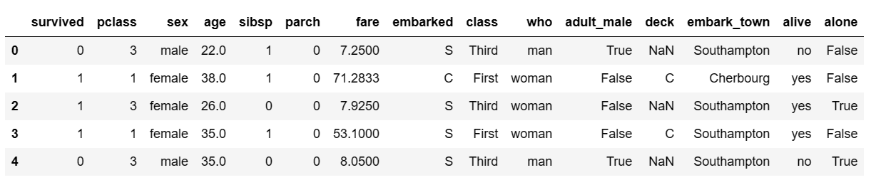

sns.distplot(x = dataset['age'], bins = 10)

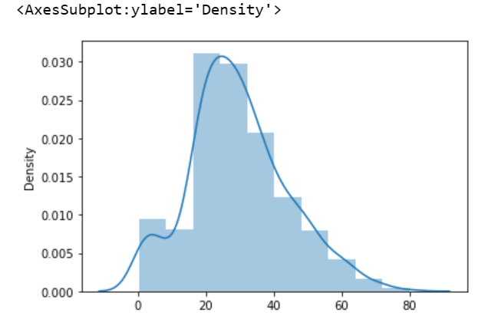

sns.distplot(dataset['age'], bins = 10,kde=False)

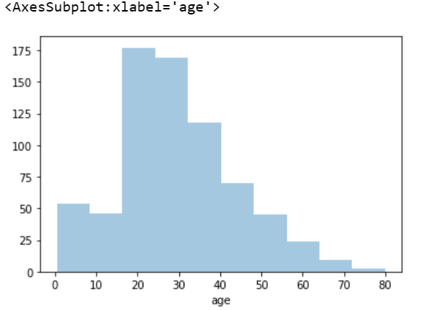

# For Plot 1

sns.jointplot(x = dataset['age'], y = dataset['fare'], kind =

'scatter')

# For Plot 2

sns.jointplot(x = dataset['age'], y = dataset['fare'], kind = 'hex')

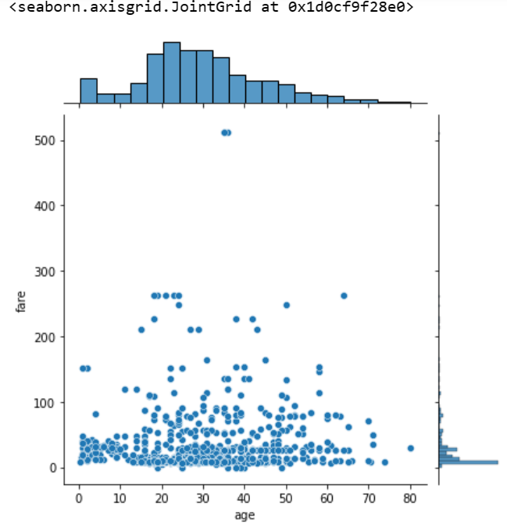

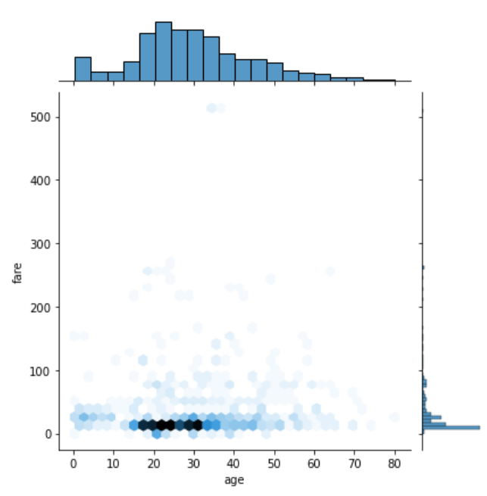

sns.rugplot(dataset['fare'])

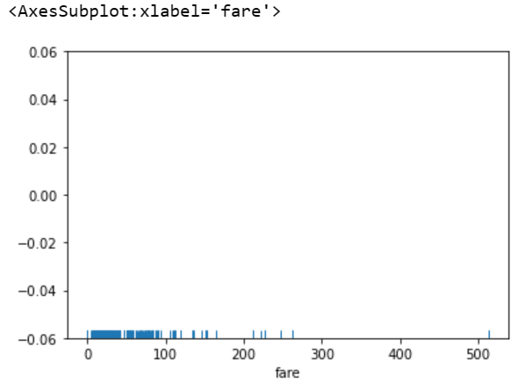

sns.barplot(x='sex',y='age', data=dataset)

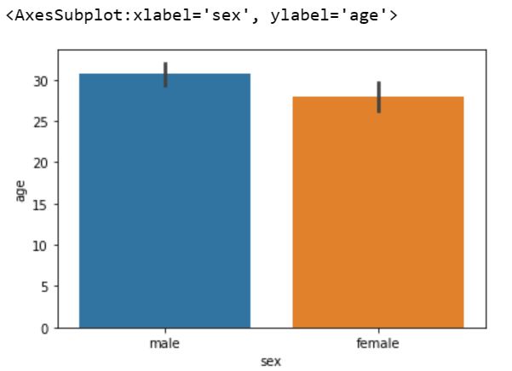

import matplotlib.pyplot as plt

sns.barplot(x='sex', y='age', data=dataset, estimator=np.std)

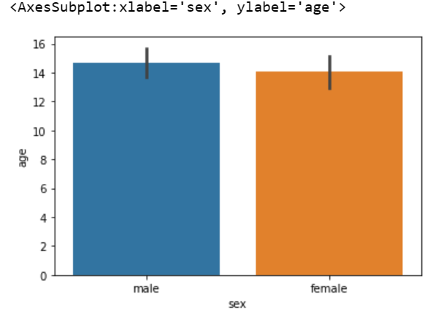

sns.countplot(x='sex', data=dataset)

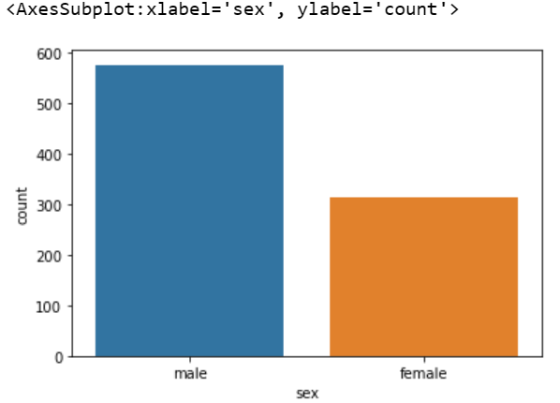

sns.boxplot(x='sex', y='age', data=dataset)

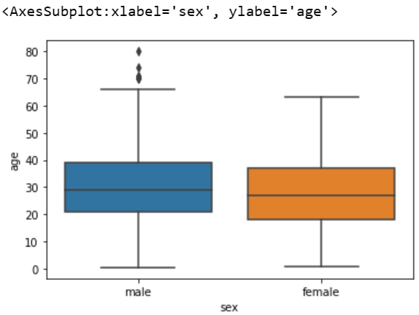

sns.boxplot(x='sex', y='age', data=dataset, hue="survived")

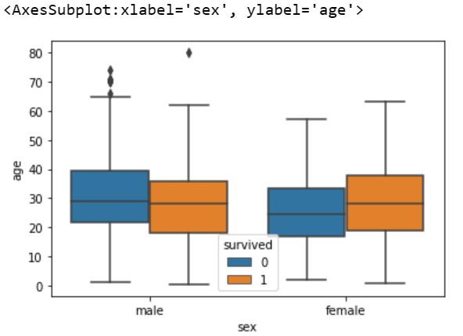

sns.violinplot(x='sex', y='age', data=dataset)

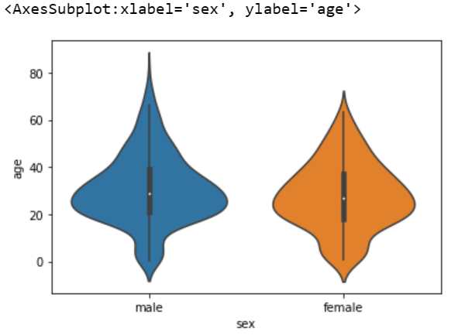

sns.stripplot(x='sex', y='age', data=dataset, jitter=False)

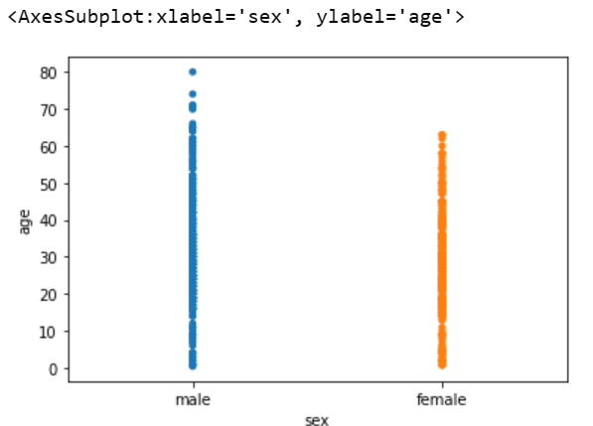

sns.stripplot(x='sex', y='age', data=dataset, jitter=True)

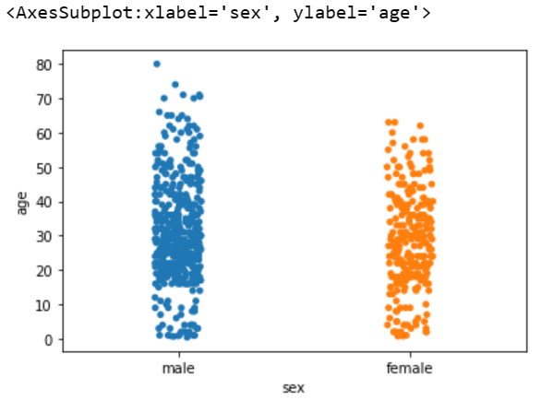

sns.stripplot(x='sex', y='age', data=dataset, jitter=True, hue='survived')

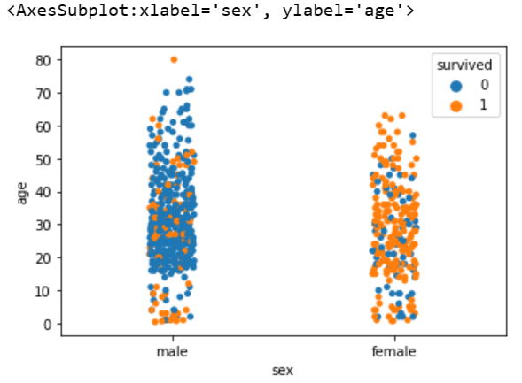

sns.swarmplot(x='sex', y='age', data=dataset)

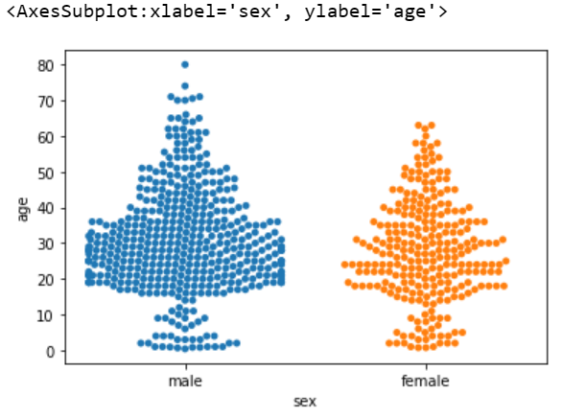

sns.swarmplot(x='sex', y='age', data=dataset,hue='survived')

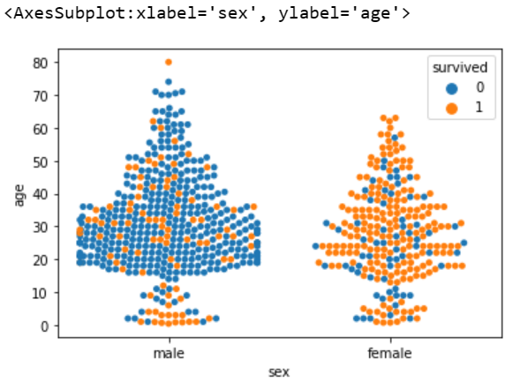

dataset.corr()

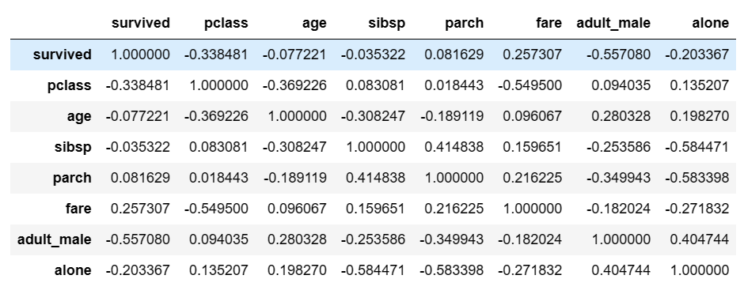

corr = dataset.corr()

sns.heatmap(corr)

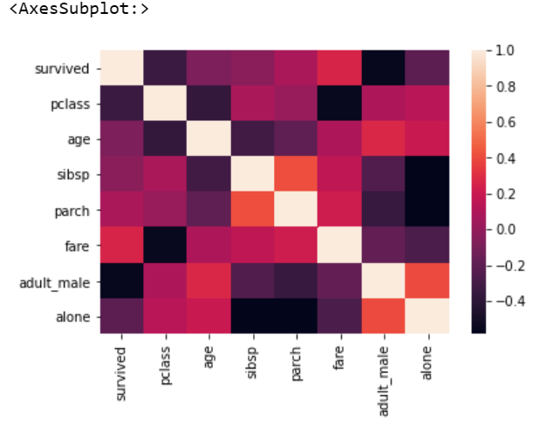

corr = dataset.corr()

sns.heatmap(corr, annot=True)

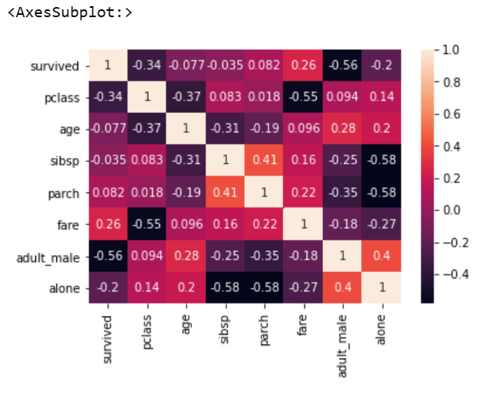

sns.histplot(dataset['fare'], kde=False, bins=10)

